Here is what I need:

-The exact number of Female and Male awards recipients in each training level.

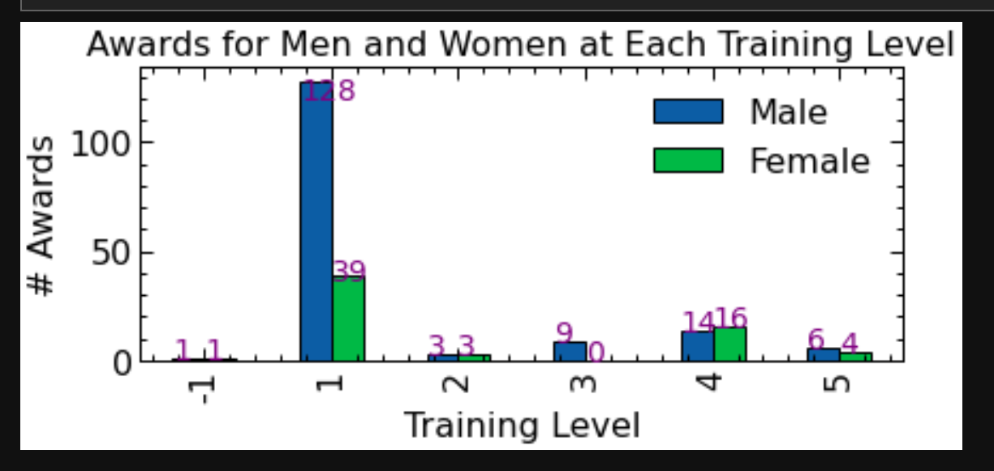

Also in each training level within each society

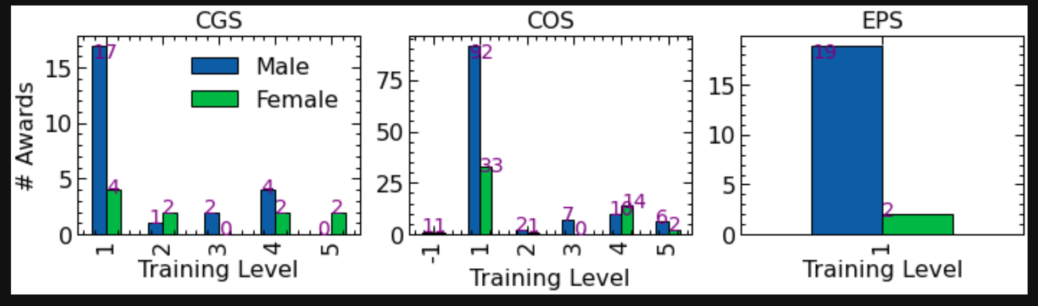

Break down category years into individual years for each society to investigate percentage of women increase

Not enough data for this: some societies data was only collected after 2010. There is also not enough data to do this on a year by year basis. Here is what the plots look like. Notice the large error bars (from not enough data)

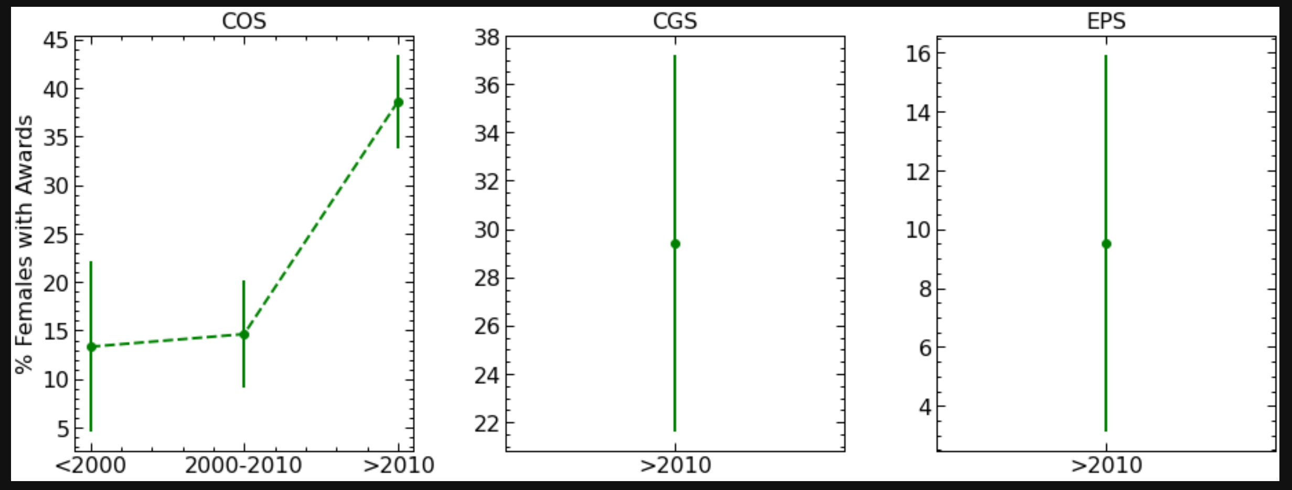

Across all societies is a little bit better:

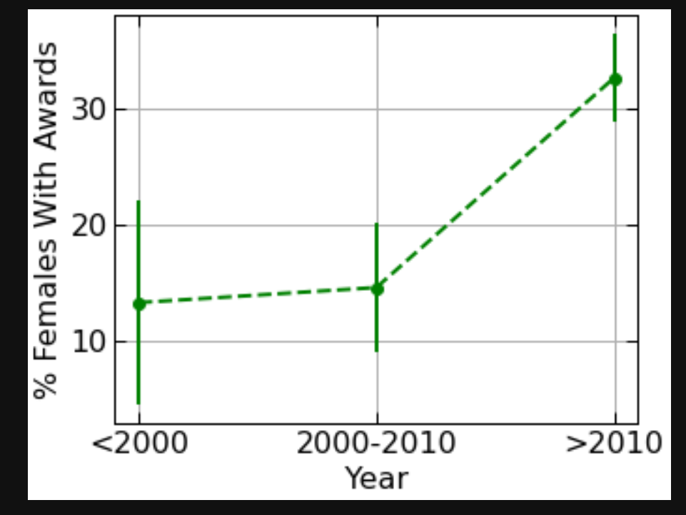

Proportions and errors (errors represent estimate of standard deviation: i.e. if you were to re-run the experiment many many times, the percentage you would obtain would very approximately 67% of the time within the interval (proportion-error, proportion+error) given a good estimate of the proportion. These errors thus represent statistical uncertainties

Years: '<2000', '2000-2010', '>2010'

Proportions: 0.13333333, 0.14634146, 0.32692308

Errors: 0.08777075, 0.05519934, 0.03755717

Number of women and men award recipients per award

I don’t have access to individual award names, only the award type and society. What I would say is that we may not have enough statistics to do any meaningful analysis on a per award basis. Rather, it would make more sense to do this based on award type

All societies

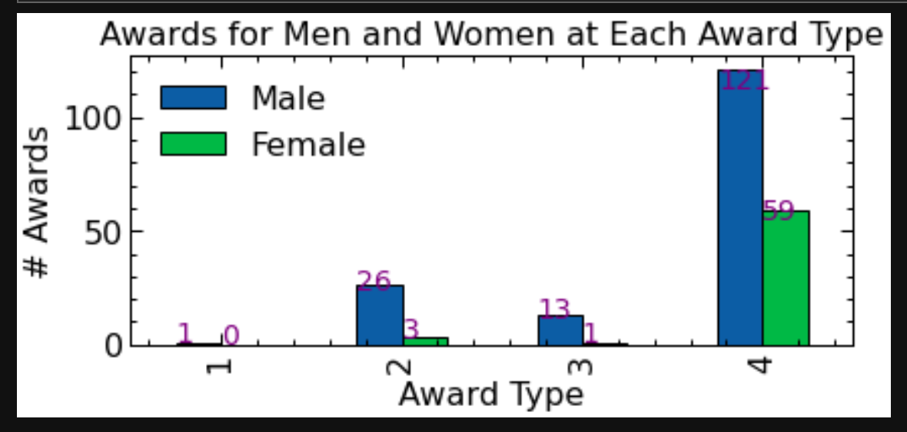

In different societies:

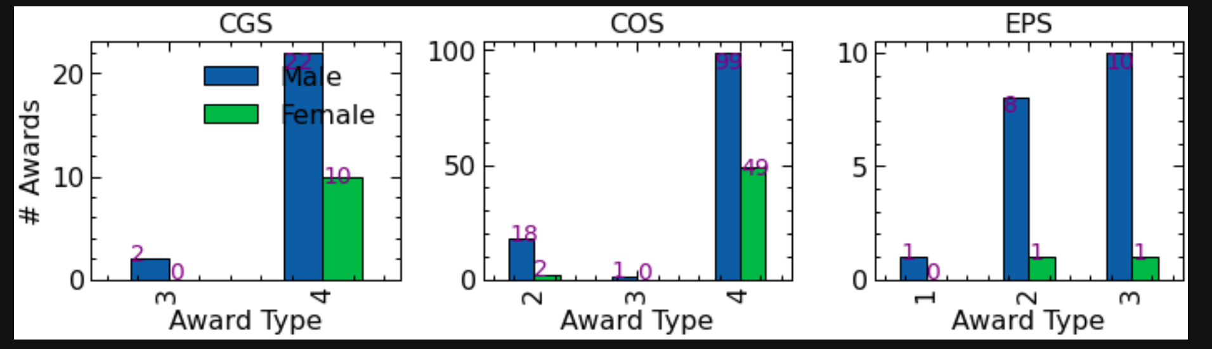

Total award winners per year; Male number; Female number

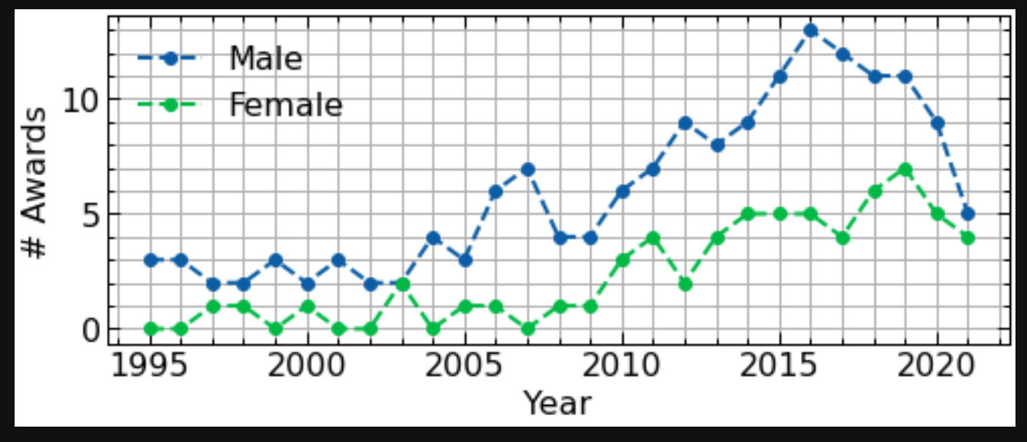

(Should be able to extract numerical values from grid). Note: It looks like more and more awards were given out but this is based on the publicly available data that you extracted